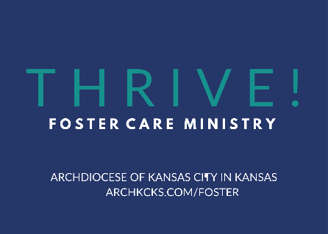

Hosting a Foster Care Awareness Event
Logistics
- Set a time and date with your parish. Weekday evenings work well for people with full-time jobs. Another option is after Sunday Mass. Keep the event to 1 hour or under.
- Book the location on your parish campus.
- Technology – Projector, Screen, Microphone, Sound system for videos.
Event Plan
- Presenters:
  - Parish Foster Ministry Coordinator as the MC
  - Pastor or Deacon to give the opening prayer
  - Personal Witness from a foster family or an adult who experienced foster care as a child (Ideally ask someone from your parish community or contact dniesen@archkck.org for suggestions)
  - A Representative from a Foster Care Agency:
    - KVC – Brandy Bartlett, Community Resource Specialist, 913.499.800/913.335.4103; bbartlett@kvc.org
    - Cornerstones of Care – Nancy Killingsworth, nancy.killingsworth@cornerstonesofcare.org
    - Saint Francis Ministries (saintfrancisministries.org)
    - TFI Family Services (tfifamily.org)
    - DCCCA – (dccca.org)
- Content
  - Archbishop Naumann’s video message – www.archkcks.org/foster
  - Foster care awareness video. We like the one from “Live the Promise” found at: https://archkcks.com/foster/how-can-my-parish-help
  - Key statistics and information of the current state of the foster care system in Kansas found at www.archkcks.com/foster/how-can-my-parish-help.
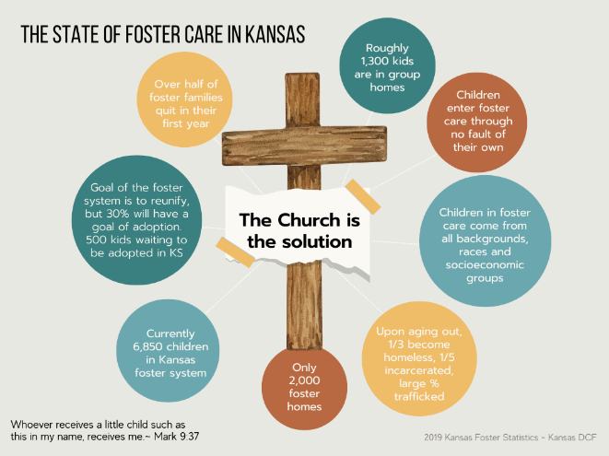
  - Personal witness story by a foster family or an adult who was in foster care as a child.
  - Presentation by a Foster Agency Representative explaining what it means to be a foster parent, why there is a need for more foster families, and the process of becoming a licensed foster family.
  - The next TIPS-MAPP (Trauma Informed Partnering for Safety and Permanence and Model Approach to Partnerships in Parenting) training.
Have a sign-up or registration table to register families the night of the event.
  - OPTIONAL: Share other opportunities for people to get involved in your parish ministry using the “Levels of Engagement” suggested actions found at www.archkcks.com/foster/how-can-my-parish-help. Consider inviting representatives or have information from our community partners such as Care Portal (careportal.org) or Joy Meadows (joymeadows.org).
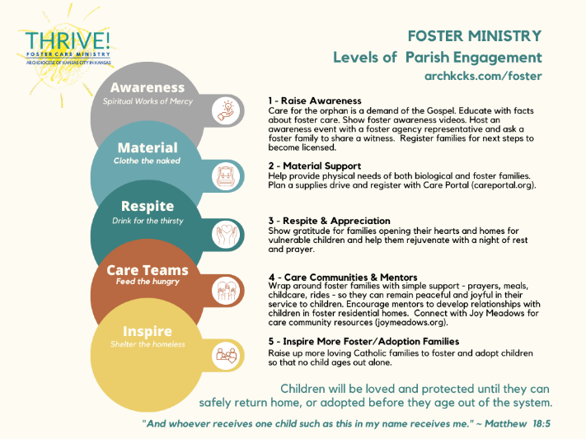
  - The Archdiocesan Foster Ministry website: www.archkcks.com/foster
  - Sign-up (or QR code) for those interested in joining your Parish Foster Ministry Team.
  - The ASK – remember to specifically ask families to take the next step to become licensed foster families. Invoke the Holy Spirit to move hearts.
Promotion
- Design a graphic for your event. It is recommended to design it in a social media post size, a flyer size and a poster size. Contact mjoerger@archkck.org in the Pro-life Office for design templates.
- Start promoting 2-3 weeks before the event.
- Promote the event in your parish bulletin, through parish social media channels, e-communications, personal invitation, or with flyers/posters.
- Be intentional about sharing the invitation with leaders of your large parish groups – Knights of Columbus, School Families, Parents of Young Children, Christ Renews His Parish teams, etc.
- Ask your pastor if you can play a foster care awareness video after Mass a week or two prior the event to increase interest. We like the one from “Live the Promise” found at: https://archkcks.com/foster/how-can-my-parish-help. There are other good video options available. If your church does not have video/audio capabilities, ask your pastor if someone could do a personal invitation during announcements at all Masses a week or two prior to increase interest.

