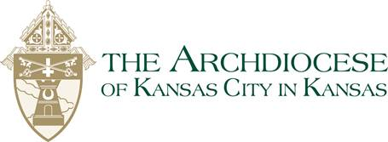
Intercessions for Foster Youth, Families, and Parishes

The Children
- For children in foster care – that they find kind, loving foster families to care for them…
- For orphaned children throughout the world, and especially those who are abused or neglected, that we might work to save them…
- For all children in foster care, who are waiting for adoptive parents or who are in danger because of their family’s circumstances, that they may experience God’s healing love through the love and care given to them by all involved in the child welfare system…
- For young people who have aged out of the foster care system, that they might find mentors to help them navigate life wisely and a community willing to support them…
Families
- For families: that they may prayerfully consider foster parenting and adoption as a means of extending God’s love through their family to children in our community…
- For all parents who struggle alone to raise their children – that God will give them the strength of the children of God and the support of His holy Church…
- For grandparents who are raising their grandchildren – that God might sustain them and reward them for their goodness and faith…
- For foster parents, who often stand in the gap for children who suffer emotional, physical and spiritual pain from their families’ circumstances, that they may know their foster children as gifts from an eternal God, who deserve to be cared for as God’s precious children…
- For foster parents and those who work in the child welfare system, that they may be the hands, feet, eyes, voice and heart of our loving God to children in foster care…
Those who work in foster care
- For those who work in the child welfare system – judges, attorneys, guardians, social workers, support staff, therapists and others – that they may shower God’s goodness and love upon the children and the families with whom they come in contact…
- For our government leaders, that lawmakers and agency directors may make wise decisions in the funding and operation of our state’s child welfare system, so the children and their families have the resources and services they need to flourish …
Our parish communities
- For our parish, as we strive to be a witness of God’s love in action, that we may embrace children in the child welfare system; their families – biological, adoptive and foster; and the volunteers and professionals in this work, and that we may sincerely seek ways to minister in this often difficult, yet essential, work…
- For our parish community, that we may be more courageous in making space for God in our lives, so we may be better guardians of the vulnerable, especially children and their families seeking our care through the child welfare system…
- For our parish community, that we may be more compassionate, so we may be present and faithful to all, but especially to children whose lives are chaotic, anxiety-filled and too often marred by violence…

